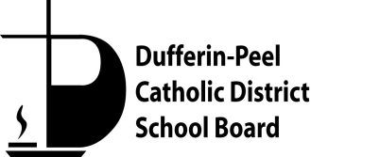

**PASTORAL PLAN**

**School: St. Nicholas Elementary School**

**School Mission Statement:**

Anchored in faith, understanding and peace, we are called through Christ and his teachings to love one another. We, the community of St. Nicholas School, recognize, celebrate and nurture the unique gifts we offer and receive to and from one another.

**School Motto:**  Faith. Understanding. Peace.

**Our Parish:** Holy Family

**Pastor: *Rev. Andrew Cyruk***

**Parish website: *https://holyfamilybo.archtoronto.org/***

**Message from the Pastor:**

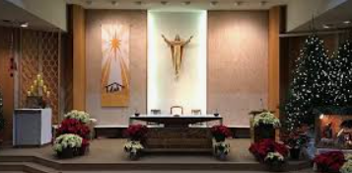Holy Family Parish recognizes how the School and Parish serve the family – the “Domestic Church”. In a sense the Family and the School are rooted in the soil we call “Parish”. Holy Family supports the faith formation of students and staff within the Holy Family School Community through liturgy, prayer, and the Sacraments. Holy Family School supports the work of evangelization in the parish through promotion of parish-wide Youth Ministries.

**Message from the Catholic School Council:**

The St. Nicholas Catholic School Council believes that our children are best served by a community in which faith, family, and learning are aligned. Our goal is to create opportunities for parents/guardians to be engaged in activities that support the development of our children and strengthen the connections between home, school and church.

**Catholic Education:** **We are Many, We are One**

L’éducation catholique: À plusieurs, nous sommes un

**APRIL 30 – MAY 5, 2023**

**Catholic Education Week:**

We are Many, We are One L’éducation catholique: À plusieurs, nous sommes un APRIL 30 – MAY 5, 2023

**Our spiritual quote for Catholic Education Week 2023 is:**

“We, who are many, are one body in Christ, and individually we are members, one of another.” (Romans 12:5) «Nous qui sommes plusieurs, nous sommes un seul corps dans le Christ, et membres les uns des autres.» (Romains 12, 5)

**Scriptural Passages for each day of Catholic Education Week**

**Monday:** When we see / En voyant “Blessed are the pure in heart for they will see God.” Matthew 5:8 «Heureux les cœurs purs, car ils verront Dieu.» Matthieu 5, 8

**Tuesday:** When we listen / En écoutant “Be quick to listen and slow to speak.” James 1:19 «Que chacun soit prompt à écouter et lent à parler.» Jacques 1, 19

**Wednesday:** When we reflect / En réfléchissant “I considered these things inwardly, and pondered them in my heart.” Wisdom 8:17 «J’ai raisonné ainsi en moi-même, j’ai pesé dans mon cœur les réflexions que voici...» Sagesse 8, 17

**Thursday:** When we learn / En apprenant “Let the wise also hear and gain in learning, and the discerning acquire skill.” Proverbs 1:5 «Que le sage écoute, il progressera encore, et l’homme intelligent apprendra à diriger.» Proverbes 1, 5

**Friday:** When we act / En agissant “I by my works will show you my faith.” James 2:18 «C’est par mes œuvres que je te montrerai ma foi.» Jacques 2, 18

**Faith Formation:**

*Forming ourselves in our Catholic faith is a foundational element in helping each of us understand and live in the example of Christ.*

|  |
| --- |
| Faith formation at St. Nicholas occurs in ways that encourage both staff and students to nurture faith development by learning more about our faith and acting as living examples of the Gospel values. At St. Nicholas, staff work to create opportunities for spiritual reflection for our students in their classrooms through liturgies, shared stories, as well as through our Religious Education and Family Life curricula. Faith formation is constant and relevant in all we do. We pray collectively at the beginning of each day, at virtual school liturgies and masses. |

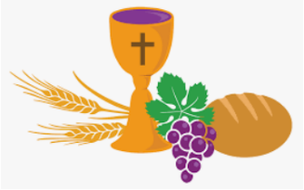**Sacramental Preparation:**

*As Catholics, we understand sacraments to be "outward signs instituted by Christ to give grace." Together in partnership with our parish, we support the preparation of God’s children in receiving the sacraments.*

**Celebrating the Sacraments at Holy Family Parish in 2023.**

Dear Parents and Guardians,

Registration to receive First Holy Communion and Confirmation at Holy Family Church in 2023, is now open. We invite students in Grade Two to register to receive their First Holy Communion and students in Grade Seven to register for the sacrament of Confirmation.

Celebration masses for these sacraments will be held in May and June of 2023.

Please visit our parish website to download the fillable registration form. holyfamilybo.archtoronto.org

Registration will close on October 16th, 2022

We pray that all students and families will have a safe and successful year.

The Sacramental Preparation Team - Holy Family Parish

**Liturgical Celebrations (Liturgies and Masses):**

*The Liturgical calendar is marked by the gathering in community to celebrate the Eucharist and share in prayer.*

|  |  |
| --- | --- |
| **Celebration** | **Date** |
| Thanksgiving Liturgy | October |
| Remembrance Day Liturgy | November |
| Advent Mass- Holy Family | Tuesday December 20th, 2022  10:30-11:30 am  Location: Holy Family Church |
| Ash Wednesday Mass- Holy Family | Wednesday February 22  In-house Mass  Ashes will be offered to the school to distribute |
| Easter Mass | Tuesday March 28th, 2022  Holy Week  10:30-11:30 am  Location: Holy Family Church |
| Confessions | TBD |
| Stations of the Cross | **Holy Week 2023 will begin on: Sunday April 2** |
| Virtue Assembly: Conscience | November |
| Virtue Assembly: Hope | December |
| Virtue Assembly: Self-Control/Decision Making | January |
| Virtue Assembly: Respect | February |
| Virtue Assembly: Kindness | March |
| Virtue Assembly: Love | April |
| Virtue Assembly: Acceptance | May |
| Virtue Assembly: Fairness | June |
| June Mass- Year End | Tuesday June 20th, 2023  10:00-11:00 am  Location: St Nicholas |
| June Mass- Graduation | Monday June 26th, 2023  6:30-8:00 pm  Location: Holy Family Church |

**Social Justice / Outreach Activities / Charities:**

*Catholic Social Teachings of the Church root our actions in supporting human dignity and the preferential option of the poor which calls us to serve the most vulnerable in the world.*

|  |
| --- |
| Throughout the year, students, staff and parents support Catholic charities, and needy families in our community and our global community. At St. Nicholas school, in an effort to live out the Gospel values, we root our actions in supporting each other and those less fortunate than us, and in caring for our environment. This year, we hope to resume some of the school wide activities that occurred in past years at the school including: the Terry Fox Run, food drives for the local community and The Giving Tree in association with Holy Family Parish. St. Nicholas staff and students participate in a variety of activities during Black History month, Autism Awareness month, and Earth Day. Students are given many opportunities to learn and support the human dignity of each person, and to serve the most vulnerable in our society. |

**Recognizing Ontario Catholic School Graduate Expectations:**

*Framed by the Ontario Catholic School Graduate Expectations (OCSGE), our graduates will be effective communicators, reflective thinkers, lifelong learners, collaborative contributors, caring family members, responsible citizens and discerning believers formed in the Catholic faith community.*

|  |
| --- |
| St. Nicholas school is focused on creating Catholic conditions for well-being and a commitment to realizing the Ontario Catholic Schools Graduate Expectations. These expectations are specific to Catholic schools and are one way we are unique in our approach to help guide students to live as Jesus did. At St. Nicholas, we model and teach the Ontario Catholic Graduation Expectations. Students are supported to become effective, reflective, self- directed, collaborative, caring and responsible citizens through their elementary journey. We celebrate our graduates through a graduation mass and present awards that recognize achievement in behaviours that reflect the OCGEs such as Christian Leadership and Catholicity. These expectations are embedded in all we do at the school. |

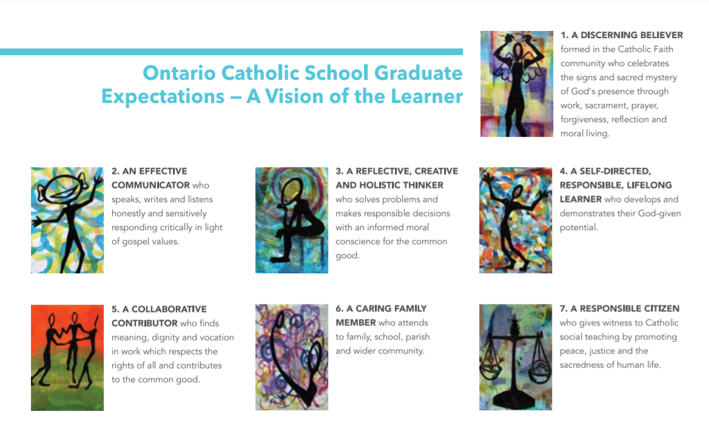

**Celebrating Virtues:**

*A virtue is a habit or established capacity to perform good actions according to a moral standard. When we practice these virtues, we strengthen them and thereby make the presence of God more and more visible in the world around us.*

|  |
| --- |
| At St. Nicholas, we encompass Catholic social teachings through the Virtues. Teaching students about the Virtues reinforce our commitment to a high moral standard. Each month a different virtue becomes a focus in our classrooms. These virtues are shared monthly in our school newsletter, during morning announcements, in student agendas, and on the school and board websites. We participate in activities such as fundraising efforts and food drives that provide opportunities for students to learn about the virtues and practice them in their daily lives. |

**Visible Signs of our Faith:**

*Through symbol and service, we are instruments of God’s love whose work within our communities stands as a witness to our faith.*

|  |
| --- |
| Visible signs and symbols of our faith are evident at St. Nicholas school. The front foyer and main office of the school welcome students, staff, parents and visitors to a faith-filled community. The signs of our faith include the altar, statue of the Blessed Virgin Mary, and scenes of the life of St. Nicholas. These are visual reminders of our common beliefs and of the liturgical seasons. The crucifix of the Risen Lord, bible, prayer tables, and classroom rosary are displayed for students, visitors and staff as visual reminders of our Catholic faith and traditions. In our actions and words, staff continue to communicate to students the values and beliefs of our shared Catholic faith, providing various connections through learning opportunities. Students’ artistic endeavors are reflective of the Liturgical seasons and are highlighted in the classrooms and throughout the school. At St Nicholas, our faith occurs during our day in our treatment and respect of others, as we all strive to be living icons of our Catholic Faith. |

**Resource List for Parents/Guardians:**

* **Religious Education Curriculum -** [Ontario Religious Education Curriculum](http://www.carfleo.org/documents/RE%20Curriculum/Elem_Rel._Ed._Policy_Document.pdf)
* **Family Life Curriculum -** [Ontario Family Life Curriculum](http://www.carfleo.org/documents/familylifeelementary/Family_Life_Education_Elementary_Policy_Document_2012.(1).pdf)
* **Fully Alive Program information -** [Ontario Bishops' information on Fully Alive](http://www.acbo.on.ca/englishweb/fullyalive.htm)

**Resource List for Schools:**

**Board**

* **Vocations Units**

We have Vocations units as part of the Grades 2, 5, and 8 curriculum. The goal of these supplementary units is to deepen one’s understanding of God’s call – the “*vocare” –* to various forms of life within the Church.

* **History of the Parish**

Through the resource book *Our Story, Our Tradition, Our Journey,* grade 7 students have the opportunity to learn about the history of our parish.

* [**Enduring Gift Video**](https://www.youtube.com/watch?v=7HsGp8C0YnA)